Working With Children Checks / VIT Registrations (Template to be used in 2024 for accreditation in 2025-2027)

**All staff, volunteers and committee members at your community language school must have a valid Working With Children Check or VIT registration, regardless of whether they have regular student contact.**

Please use this template to provide the details of the Working With Children Check and/or VIT registration for each staff member, volunteer and committee member at your school. Please note that you do not need to submit copies of the cards, but you must keep copies on file at your school.

**Instructions:**

1. Check through all the documents that you are submitting for accreditation, and make sure every staff member, volunteer and committee member who has been named in a document has a valid Working With Children Check, and has been included in this document.
2. Complete the table by copying the details EXACTLY as they appear on the person’s card. This is very important.
3. In the first column, write the person’s first/given name(s) and any initials, e.g. “John B”. In the second column, write down the person’s family name/surname, e.g. “CITIZEN”. On the card, the family name is usually written in capital letters. A sample is shown below.
4. Submit this template **in Word format** with the **filename “05_workingwithchildren”**.

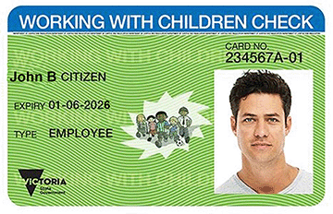

Sample

| **First/Given Name(s)** | **FAMILY NAME / SURNAME** | **Other names  by which this person is known** | **Position in school** | **Campus** | **Working With Children Check** | | **Victorian Institute of Teaching** | |
| --- | --- | --- | --- | --- | --- | --- | --- | --- |
| **Card Number** | **Card  Expiry Date** | **Registration Number** | **Registration Expiry Date** |
| John B | CITIZEN | Jack | Teacher | Flemington | 234567A | 01-06-2026 |  |  |

| **First/Given Name(s)** | **FAMILY NAME / SURNAME** | **Other names  by which this person is known** | **Position in school** | **Campus** | **Working With Children Check** | | **Victorian Institute of Teaching** | |
| --- | --- | --- | --- | --- | --- | --- | --- | --- |
| **Card Number** | **Card  Expiry Date** | **Registration Number** | **Registration Expiry Date** |
|  |  |  |  |  |  |  |  |  |
|  |  |  |  |  |  |  |  |  |
|  |  |  |  |  |  |  |  |  |
|  |  |  |  |  |  |  |  |  |
|  |  |  |  |  |  |  |  |  |
|  |  |  |  |  |  |  |  |  |
|  |  |  |  |  |  |  |  |  |
|  |  |  |  |  |  |  |  |  |
|  |  |  |  |  |  |  |  |  |